https://www.jdoodle.com/embed/v0/5PRZ
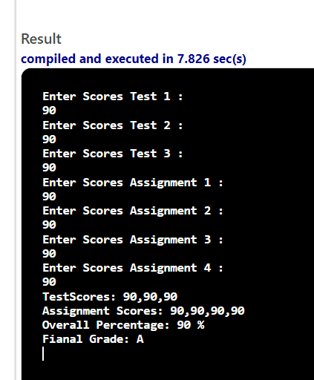
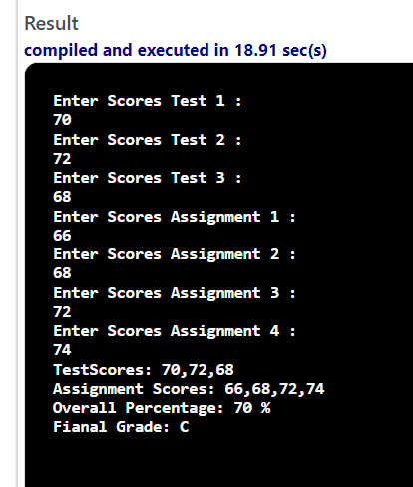

#include <iostream>

using namespace std;

int main() {
double t1, t2, t3, a1, a2, a3, a4, pct;
string grade;
cout<<"Enter Scores Test 1 :"<<endl;
cin>>t1;
cout<<"Enter Scores Test 2 :"<<endl;
cin>>t2;
cout<<"Enter Scores Test 3 :"<<endl
cin>>t3;
cout<<"Enter Scores Assignment 1 :"<<endl;
cin>>a1;
cout<<"Enter Scores Assignment 2 :"<<endl;
cin>>a2;
cout<<"Enter Scores Assignment 3 :"<<endl;
cin>>a3;
cout<<"Enter Scores Assignment 4 :"<<endl;
cin>>a4;
//compute the overall percentage scores
pct = ( ( (t1 + t2 + t3 ) / 3.0 ) * .70 ) + ( ( ( a1 + a2 + a3 + a4 ) / 4.0 ) * .30 );

if (pct >= 90) {

grade = "A";

}

else if (pct >= 80) {

grade = "B";

}

else if (pct >= 70) {

grade = "C";

}

cout<<"TestScores: "<<t1<<","<<t2<<","<<t3<<endl;
cout<<"Assignment Scores: "<<a1<<","<<a2<<","<<a3<<","<<a4<<endl;
cout<<"Overall Percentage: "<<pct<<" %"<<endl;
cout<<"Final Grade: "<<grade<<endl;
return 0;
}

